Article title - English English (TNR bold 14 pt)

First name Last name (TNR bold 12 points)

Name of the University (or other affiliation) (TNR 10 points)
Name of the Faculty and/or Institute/Department (if necessary) (TNR 10 points)
e-mail: please enter your e-mail address here; ORCID: please enter the ORCID number here (TNR 10 points)

Abstract. 250 – 500 words, with a full stop at the end. The abstract must be a concise description of the work, which includes the following issues (a necessary condition!): a short summary of the issue with justification for its inclusion in the scientific article, the purpose of the research, hypotheses, methodology (presentation of the theories and research methods used), results (concise summary most important results obtained) and conclusions. The abstract is published separately in many indexing databases, so it should be complete.
Keywords: between 3 and 5 keywords

Introduction (TNR bold 12 pts)
Text Text Text Text Text Text Text Text Text Text Text Text Text Text Text Text Text Text Text Text Text Text Text Text Text Text Text Text Text Text Text Text Text (12 TNR).
Subsection title (12 TNR bold)
Text Text Text Text Text Text Text Text Text Text Text Text Text Text Text Text Text Text Text Text Text Text Text Text Text Text Text Text Text Text Text Text Text (12 TNR).

Subsection title (12 TNR bold, italics)
Text Text Text Text Text Text Text Text Text Text Text Text Text Text Text Text Text Text Text Text Text Text Text Text Text Text Text Text Text Text Text Text Text (12 TNR).

Summary (TNR bold 12 pts)
Text Text Text Text Text Text Text Text Text Text Text Text Text Text Text Text Text Text Text Text Text Text Text Text Text Text Text Text Text Text Text Text Text (12 TNR).

NOTES IN THE TEXT:
• Footnotes should be placed directly in the text (in brackets) in the following order: (Author's name, year of publication, page numbers), e.g. (Woźniak, 2009a, pp. 95-96).
• If in the bibliographic footnotes there is a reference to at least two works by the same author published in the same year, in order to avoid ambiguity, a letter of the alphabet should be added immediately after the year), e.g. (Woźniak, 2009a, pp. 95-96), ( Woźniak, 2009b, pp. 10-25).
• In the case of websites, instead of the name of the Author (if it cannot be identified), enter the name of the portal/website/enterprise/office, etc.), e.g. (GUS, 2014).
• For online sources, the page number is not required.
• In the case of Internet sources, the year of publication of the given material should be entered as the year of publication, not the year of downloading the material by the Author. If the date of publication of the material on the Internet cannot be indicated, the year of downloading the material by the Author may be given in the footnote).
• In the case of multi-author studies (4 or more authors), enter only the name of the first author with the note et al. in parentheses, e.g. (Wereda et al., 2015, pp. 77-79).

TABLES AND DRAWINGS/DIAGRAMS/GRAPHS/PHOTOS:
• Tables and drawings/diagrams/diagrams should be placed in the text as close as possible to the place of reference to them.
• The title of the table should be placed above the table (TNR 10 points).
• The title of the drawing/diagram/diagram/photo should be placed under this graphic form (TNR 10 points).
• The title of the table is written in italics, and the title of the drawing/diagram/chart/photo in simple letters.
• Each table and each drawing/scheme/diagram/photo (for a vertical page layout) must not exceed 126mm horizontally and 189mm vertically.
• When citing sources for drawings/diagrams/charts/photos and tables, parentheses are not added.
• Under each table, figure or other graphic form, the source or information should be given
"based on" or "own study" (TNR 10 points).
• The size of text in drawings/diagrams/charts and tables is 7-9 points. TNR.
• Text in tables is written in Times New Roman (TNR), and in drawings/diagrams/graphs – Arial Narrow (AN).
• Drawings/diagrams/diagrams should be made in graphic programs.
• If the drawing/scheme is made in MS Word, AutoShapes should be grouped.
The article sent to the Editorial Office should be accompanied by a file in .pdf format or a folder with
drawings/diagrams in .jpg, .png, .tiff, .gif or similar formats. The minimum resolution of the drawing/scheme, especially photos and scans, should be 300 dpi.
• Drawings/diagrams can be made in color or shades of grey. It is proposed to use color only where it is really needed.

EXAMPLES:

Table 1. Popularity of the Google Play platform in the world
Data | Liczba aplikacji | Liczba pobrań aplikacji
marzec 2009 | 2 300 | b.d.
grudzień 2009 | 20 000 | b.d.
sierpień 2010 | 80 000 | 1 miliard
maj 2011 | 200 000 | 3 miliardy
lipiec 2011 | 250 000 | 6 miliardów
listopad 2011 | 370 000 | 7 miliardów
grudzień 2011 | 370 000 | 10 miliardów
styczeń 2012 | 400 000 | n.d.
luty 2012 | 450 000 | n.d.
lipiec 2013 | 1 000 000 | 50 miliardów
n.d. - no data.

Source: Wikipedia, 2014b

Table 2. Basic benefits for the development of global activity resulting from the use of licenses - on the example of Google Play licenses
Lp. | Korzyści dla rozwoju działalności globalnej firmy Google
1. | Ograniczenie nakładów inwestycyjnych ze strony Google na wytwarzanie aplikacji podlegających sprzedaży w sklepie. Dzięki sprzedaży możliwe jest pozyskiwanie nowych rynków oraz umacnianie marki wśród internautów – natomiast Google nie  musi ponosić bezpośrednich kosztów wytworzenia aplikacji.
2. | Otrzymywanie opłat licencyjnych od programistów za dostęp do konta  deweloperskiego oraz ze sprzedaży urządzeń mobilnych z systemem Android, który umożliwia obsługę sklepu.
3. | Ograniczone ryzyko handlowe – ewentualna niska sprzedaż aplikacji lub reklamacje dotyczą programisty, a nie platformy Google Play.
4. | Niskie koszty kształtowania wizerunku na poszczególnych rynkach – kształtowanie wizerunku odbywa się za pośrednictwem sprzedawanych aplikacji.
5. | Możliwość prowadzenia ekspansji globalnej (wystarczy dostęp – zarówno u  programisty, jak i klienta – do Internetu).
Source: own study based on: Google, 2014c; Gorynia, 2007, pp. 115-116; Rymarczyk, 2004, p. 177
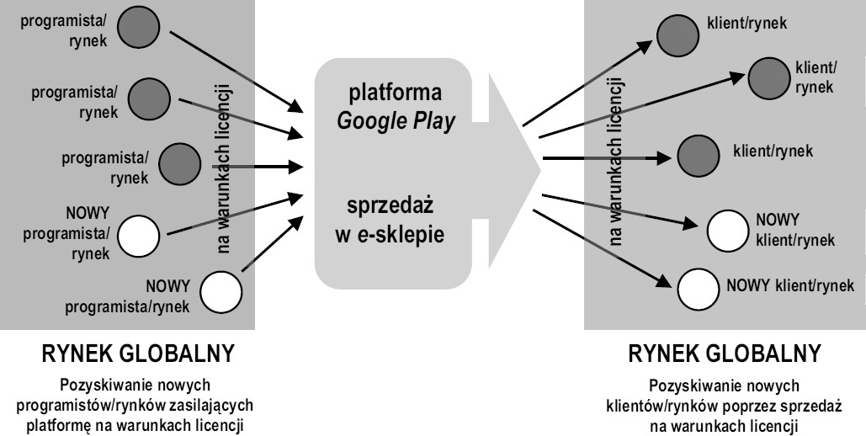
Fig. 1. Internationalization mechanism based on the Google Play license
Source: own study

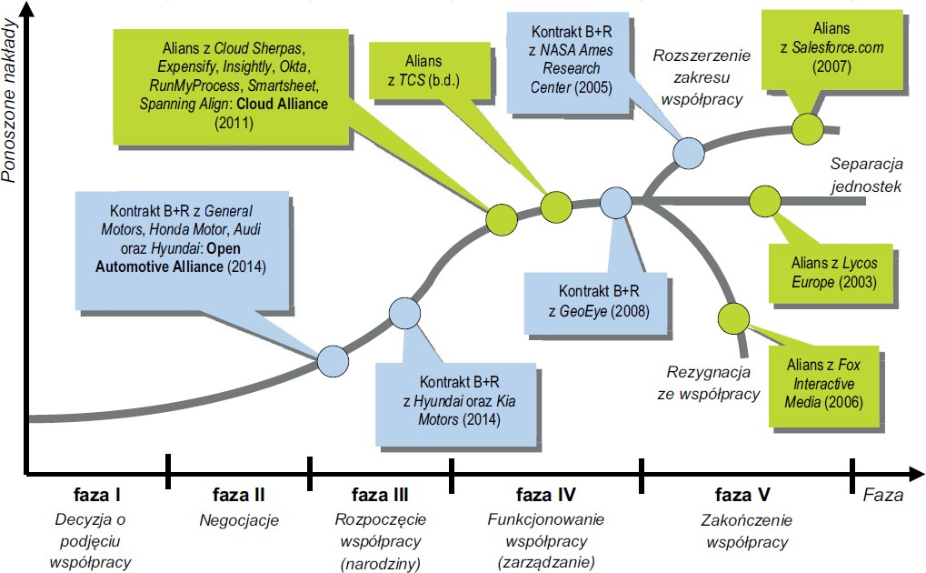
The year in which the alliance or the R&D contract was established is given in parentheses.
n. d. - no data.

Fig. 2. Stages of life cycles of selected cooperations (alliances and R&D contracts) of Google (as of 2014)
Source: own study based on analyzes and predictions of the authors of the study
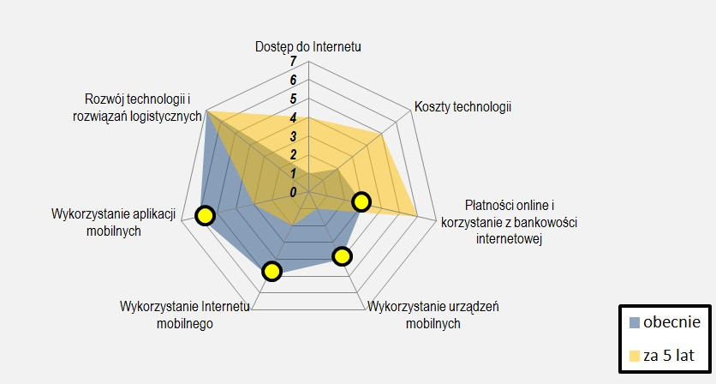
Chart 1. Change in the significance of technological factors
Source: own study
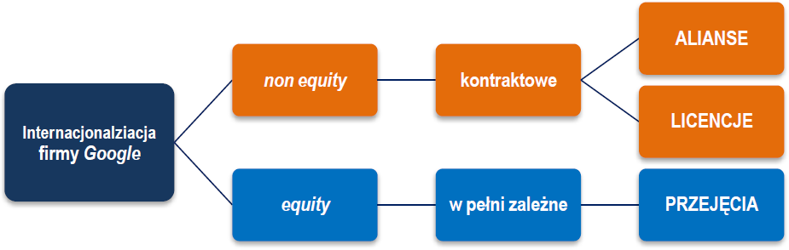
Scheme 1. Selected forms of Google's internationalization - classification by Y. Pan
Source: own study

BIBLIOGRAPHY (10 TNR) (formatting example)

- Battelle J., 2007, Szukaj. Jak Google i konkurencja wywołali biznesową i kulturową rewolucję, Wydawnictwo Naukowe PWN, Warszawa.
- Bendyk E., 2011, Sposób na nadmiar informacji, „Polityka”, wydanie specjalne: „Niezbędnik Inteligenta Plus”, nr 8.
- Brandt R.L., 2011, Potęga Google’a, Znak, Kraków.
- Brycz B., Dudycz T., 2010, Case study jako popularna metoda w naukach o zarządzaniu, „Kwartalnik Nauk o Przedsiębiorstwie”, nr 3 (16).
- Cygler J., 2002, Alianse strategiczne, Difin, Warszawa.
- Das T.K., Teng B.-S., 2002, A Social Exchange Theory of Strategic Alliances, [w:] F.J. Contractor, P. Lorange (Eds.), Elsevier, Oxford.
- Flyvbjerg B., 2004, Five misunderstandings about case-study research, [in:] C. Seale, G. Gobo, J.F. Gubrium, D. Silverman (Eds.), Qualitative Research Practice, Sage, London and Thou-sand Oaks, CA.
- Gorynia M., 2007, Strategie zagranicznej ekspansji przedsiębiorstw, Polskie Wydawnictwo Ekonomiczne, Warszawa.
- Karaś M., 2014, Studium przypadku jako narzędzie badawcze, [w:] K. Kuciński (red.), Naukowe badanie zjawisk gospodarczych. Perspektywa metodologiczna, Wolters Kluwer, Warszawa.
- Mecki R., 1995, Zur Planung internationaler Unternehmenskooperation, „Zeitschrift für Planung”, Nr. 1.

NETOGRAPHY (10 TNR) (formatting example)

- Brian M., 2013, Google partners with Hyundai and Kia Motors to integrate Google Maps and Places into new car models, http://thenextweb.com/google/2013/01/02/google-partners-with-kia-motors-to-integrate-google-maps-and-places-into-new-car-models/?fromcat=all (15.05.2014).
- Chickowski E., 2011, Top Google Partners Form Cloud Alliance, http://www.channelinsider.com/c/a/Cloud-Computing/Top-Google-Partners-Form-Cloud-Alliance-288634/ (17.05.2014).
- Cools K., Roos A., 2008, The strategic logic of alliance, Boston Consulting Group, http://www.bcg.com/documents/file14835.pdf (12.07.2014).
- Dobreprogramy, 2013, http://www.dobreprogramy.pl/Statystyki-urzadzen-mobilnych-w-Q3-2013-Android-kontynuujedominacje-a-Windows-Phone-podwaja-udzial-w-rynku,News,49002.html (17.05.2014).
- Gazeta Prawna, 2014, http://biznes.gazetaprawna.pl/artykuly/798695,najcenniejsze-marki-swiata-2014-google-pokonalo-apple.html (15.07.2014).
- Google, 2014a, Fox Interactive Media Enters Into Landmark Agreement with Google Inc., http://investor.google.com/releases/2006/0807.html (14.05.2014).
- Google, 2014b, https://www.google.pl/mobile/play/#promo-1 (17.05.2014).
- Salesforce, 2014, Salesforce.com and Google Form Strategic Global Alliance, http://www.salesforce.com/company/news-press/press-releases/2007/06/070605.jsp (16.05.2014).

NOTE: for materials from the Internet, the date of access (in parentheses) should be provided.

